SIMATS ENGINEERING
ECA5603 – 5G/6G COMMUNICATION SYSTEMS
CO1 INTEGRATED ENGINEERING ANALYSIS AND PLANNING ASSIGNMENT
Evolution, Cellular Planning, Spectrum Use and Interference Management

Student details | Information
Name | Mohamed Affan
Register Number | 192512365
Faculty | Kalaiarasi K
Course Code | ECA5603
Course Title | 5G/6G Communication Systems
Assignment | CO1 Integrated Engineering Analysis and Planning Assignment

Abstract
This report analyzes a regional mobile network using the supplied planning values: a hexagonal cell radius of 2 km, a 19-cell planning cluster, reuse cluster size N = 7, 1,000 subscribers generating 0.08 Erlang each, an initial 100-channel base station, and a blocking target of 2%. It compares mobile generations from 1G to the 6G vision, estimates cell geometry and reuse, evaluates Erlang-B traffic capacity, examines handoff behavior, calculates interference and free-space path loss, and proposes a phased deployment strategy. Calculations are idealized planning estimates; final engineering requires measured propagation, actual spectrum assignments, traffic distributions, and site-level radio planning.

1. Introduction and problem definition
The planning objective is to recommend a practical network evolution path that balances coverage, capacity, service continuity, interference, and deployment cost. The network must support conventional mobile broadband as well as delay-sensitive vehicle and industrial applications. The supplied assignment data are treated as the controlling inputs; assumptions introduced for interpretation are stated explicitly.

1.1 Design requirements
Requirement | Engineering interpretation / indicator
Coverage | Geometric coverage is a starting estimate; verify radio coverage using field measurements and link budgets.
Capacity | Busy-hour offered traffic = subscribers × Erlang/subscriber; blocking probability target ≤ 2%.
Mobility | Maintain continuity across cells; compare overlap dwell time and handoff interruption.
Interference | Check C/I and SINR against the specified 15 dB target.
Spectrum | Compare 900 MHz, 3.5 GHz and 28 GHz at 100 m using the given free-space model.
Evolution | Preserve a migration path from current 5G NR capability to emerging 6G concepts.

1.2 Assumptions and limitations
- Cells are modeled as regular hexagons with radius r = 2 km; real cell boundaries are irregular because of terrain, buildings, antenna patterns and interference.
- The 1,000 subscribers are assumed to offer independent traffic at 0.08 Erlang per subscriber during the busy hour, giving 80 Erlangs total.
- Erlang B assumes a loss system with no waiting queue and statistically independent call arrivals/holding times; the calculation is a first-order traffic estimate.
- Free-space path loss excludes foliage, walls, shadowing, antenna gains, feeder losses, fading and atmospheric effects.
- For handoff risk, the 1% cell unavailability is treated as an illustrative independent probability at the handoff instant; this is not a complete call-drop model.

2. Evolution of mobile communication systems
Generation | Supplied example / radio method | Main service or change | Limitation / engineering implication
1G | AMPS, 800 MHz; analog FDMA, 30 kHz channels | Basic analog voice | Limited capacity and privacy; frequency reuse and interference constrain service.
2G | GSM, 900 MHz; 200 kHz carrier with 8 TDMA slots | Digital voice and improved spectrum use | Digital scheduling improves capacity, but data rates and latency remain limited.
3G | UMTS, 5 MHz carrier | Mobile data and multimedia | Higher data demand required improved spectral efficiency and packet services.
4G | LTE; OFDMA and MIMO | Broadband IP services | Capacity depends on bandwidth, spatial multiplexing, scheduling and radio conditions.
5G | NR; eMBB, URLLC, mMTC; mid-band/mmWave; beamforming | Broadband, low-latency services and massive IoT | Different services need differentiated QoS, slicing, dense cells and robust mobility.
6G vision | THz, AI-native networking, holographic communication, tactile internet, ISAC | Potentially integrated sensing and communications with very high data rates | Research vision; spectrum, propagation, hardware, energy and standardization remain open issues.

2.1 1G wavelength and idealized channel count
Wavelength is λ = c/f. At f = 800 MHz, λ = (3 × 10⁸ m/s)/(800 × 10⁶ Hz) = 0.375 m.
Idealized number of 30 kHz channels in 10 MHz = 10,000 kHz / 30 kHz = 333.33, so at most 333 complete 30 kHz channels fit arithmetically.
This is an idealized count only. It ignores guard bands, duplexing, control/signaling allocations, channel raster constraints and other practical spectrum overheads, as required to be stated in the assignment. Actual usable traffic-channel count is lower.
In GSM, the 200 kHz carrier is divided into eight TDMA time slots. This digital time-sharing and digital processing improve resource use and service capabilities relative to analog 1G, although real network capacity also depends on coding, reuse, control channels and interference.

3. Cell coverage and frequency reuse

3.1 Hexagonal cell area and 19-cell cluster
For a regular hexagon with cell radius r (centre-to-vertex), area A = (3√3/2)r². With r = 2 km: A = (3√3/2)(2 km)² = 10.392 km² per cell.
For 19 cells, the idealized cluster area is 19 × 10.392 = 197.454 km². This is a geometric sum, not a guarantee that radio service is available everywhere inside that area.
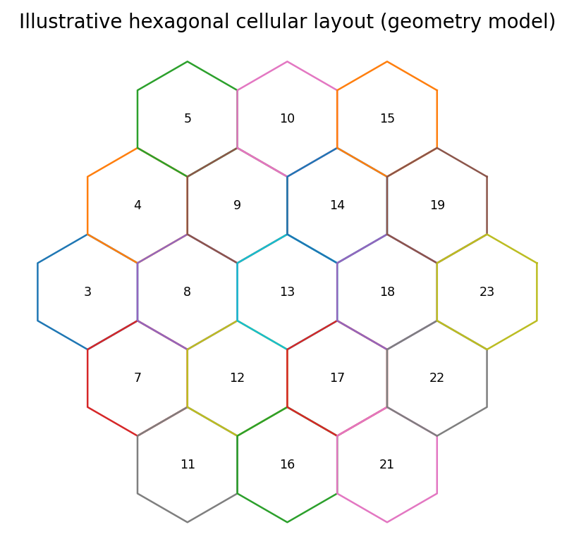
Figure 2. Illustrative hexagonal cell geometry; real cell shapes vary with propagation and site layout.

3.2 Reuse fraction and reuse distance
The supplied reuse cluster size is N = 7. The frequency reuse fraction is 1/N = 1/7 = 0.1429 (14.29%), meaning each cell in a seven-cell reuse pattern is assigned one-seventh of the total available frequency resource under the idealized model.
Co-channel reuse distance: D = r√(3N) = 2√(21) = 9.165 km. The ratio D/r = 4.583. This assumes a regular hexagonal lattice and idealized reuse geometry; actual interference depends on antenna patterns, sectorization, terrain, traffic and power control.

3.3 Capacity expansion options
Measure | Benefit | Trade-off / use case
Cell splitting | Adds smaller cells and increases spatial reuse | More sites, backhaul and handoffs; may raise interference if poorly planned.
Sectoring | Directional antennas reduce the number of dominant interferers | Additional antenna/ RF complexity; sector-edge performance needs planning.
Microcells | Improve capacity along streets, campuses and dense corridors | Require closer site spacing and more frequent mobility events.
Picocells | Add indoor or localized capacity in stations, malls and hospitals | Limited coverage; require backhaul and interference coordination.
Femtocells | Localized indoor coverage, often user-premises based | Access control, interference and management are important.
Macro cells | Broad-area coverage and mobility anchor | May be capacity-limited in dense hotspots.

Recommendation: retain macro cells as the coverage and mobility layer, then add micro/pico cells at measured congestion hotspots and transport hubs. Apply sectorization or cell splitting only where drive tests and busy-hour utilization identify a clear capacity need. This avoids blanket densification, which would increase cost, power use and handoff frequency.

4. Traffic capacity and Erlang B analysis

4.1 Offered busy-hour traffic
Offered traffic A = number of subscribers × traffic per subscriber = 1,000 × 0.08 Erlang = 80 Erlangs.
Erlang B blocking probability for C channels is calculated recursively: B(0,A) = 1 and B(c,A) = [A × B(c−1,A)]/[c + A × B(c−1,A)]. The model assumes blocked calls are cleared rather than queued.

4.2 Blocking result and minimum channels
Case | Input / method | Result | Interpretation
Initial base station | A = 80 Erlangs; C = 100 channels; Erlang B recursion | B(100,80) ≈ 0.003992 = 0.399% | The modeled blocking probability is below the 2% target.
Minimum channels | Increase C until B(C,80) ≤ 0.02 | C = 92 gives B ≈ 1.922%; C = 91 does not meet target | 92 is the minimum integer channel count for the stated offered load.
100-channel groups | ceil(92/100) | 1 group | One 100-channel group is enough for the aggregate modeled load, but this does not specify physical site count.

Interpretation: 100 channels provide margin relative to the 92-channel minimum for 80 Erlangs. However, channels cannot necessarily be pooled across an entire region without regard to geography. Real deployment must distribute capacity by cell, account for nonuniform busy-hour demand, control channels, handoff traffic, spectrum licensing and frequency reuse. The “one group” result is therefore only a first-order traffic estimate, not a complete site plan.

4.3 Capacity relationship
A useful theoretical upper bound is Shannon capacity C = B log₂(1 + SNR), where B is bandwidth in hertz. A practical first-order data-rate estimate is R ≈ Bη, where η is spectral efficiency in bit/s/Hz. Actual throughput is lower due to interference, coding and modulation constraints, protocol overhead, scheduling and retransmissions.

5. Mobility and handoff analysis

5.1 Distance travelled during overlap
Speed = 60 km/h = 60,000 m / 3,600 s = 16.667 m/s. Distance in a 6 s overlap zone = vt = 16.667 × 6 = 100 m.

5.2 Handoffs per minute
Using the supplied nominal route cell length of 1 km as the distance travelled between successive cell transitions, travel time per cell = 1 km / 60 km/h = 1/60 h = 60 s. The estimated rate is therefore about 1 handoff per minute during continuous travel along that route. This is a simplified interpretation; actual handoff rate depends on cell geometry, route direction, overlap, speed and radio conditions.

5.3 Handoff types and simple risk estimate
Handoff type | Continuity / resource use | Typical implication
Hard handoff | Break-before-make; releases old connection before or as new one is established | Efficient resource use, but interruption or drop risk if target link is not ready.
Soft handoff | Make-before-break with simultaneous links, classically in CDMA systems | Can improve continuity but consumes resources on multiple cells.
Softer handoff | Make-before-break between sectors of the same base station | Can improve sector-boundary continuity with additional radio resource use.

A simple overlap travel-time comparison gives interruption fraction = 0.5 s / 6 s = 8.33% of the overlap interval. Separately, if the target cell is unavailable 1% of the time and that unavailability is independent of handoff timing, a one-handoff unavailability risk proxy is 1%. These two figures describe different effects and must not be added as if they were a validated call-drop probability. The 0.5 s interruption may affect real-time services, while a complete drop estimate needs target-cell selection, radio-link failure, retries, handover preparation and failure statistics.
Recommendation: use make-before-break where supported and justified for critical mobility, optimize neighbor lists and handover thresholds, and test at 60 km/h along transport corridors. Measure interruption, handover success rate, ping-pong rate and radio-link failures.

6. Interference analysis

6.1 Carrier-to-interference ratio with co-channel interference only
Desired signal S = −70 dBm and co-channel interference I₁ = −85 dBm. C/I = S − I₁ = (−70) − (−85) = 15 dB. The co-channel-only ratio is exactly at the specified 15 dB threshold.

6.2 Combined co-channel and adjacent-channel interference
Interference powers must be summed in linear units, not directly in dBm. In mW: I₁ = 10^(−85/10) = 3.1623 × 10⁻⁹ mW; I₂ = 10^(−90/10) = 1.0000 × 10⁻⁹ mW.
I_total = I₁ + I₂ = 4.1623 × 10⁻⁹ mW. Converting back: I_total(dBm) = 10 log₁₀(I_total in mW) ≈ −83.81 dBm.
SINR ≈ S − I_total = −70 − (−83.81) = 13.81 dB (thermal noise is not included because no noise value was supplied). This is below the 15 dB target by about 1.19 dB. Therefore, the case fails the target when both interference components are included.
Interference case | Calculated result | Target decision
Co-channel only | C/I = 15.00 dB | Meets threshold exactly.
Co-channel + adjacent-channel | Combined interference ≈ −83.81 dBm; signal-to-interference ratio ≈ 13.81 dB | Does not meet 15 dB target; additional margin is needed.

6.3 Mitigation and trade-offs
Use coordinated frequency planning and antenna/beam optimization to reduce dominant co-channel coupling; improve adjacent-channel filtering and ensure adequate channel separation where feasible. Sectorization, beamforming and power control can reduce interference, but may add hardware/control complexity and must not create coverage holes. A practical design target should include margin above 15 dB rather than merely meeting the threshold in an ideal case.

7. Spectrum-band comparison at 100 m
Wavelength is λ = c/f, with c = 3 × 10⁸ m/s. Free-space path loss is FSPL = 20 log₁₀(4πd/λ), using d = 100 m. The model assumes unobstructed free-space propagation.
Frequency | Wavelength λ | FSPL at 100 m | Difference vs 900 MHz | Planning interpretation
900 MHz | 0.3333 m | 71.53 dB | 0 dB | Better general coverage and penetration; suitable for rural/low-band coverage, but bandwidth may be limited.
3.5 GHz | 0.0857 m | 83.32 dB | +11.80 dB | Useful coverage-capacity balance for urban/suburban areas; denser sites than low-band may be required.
28 GHz | 0.0107 m | 101.38 dB | +29.86 dB | Large bandwidth potential and compact arrays; blockage and penetration challenges make it best for hotspots and short high-capacity links.

Higher frequency increases free-space loss at the same distance in this comparison, but it does not alone determine achievable performance. Available bandwidth, antenna aperture and gain, beamforming, transmitter power limits, receiver noise, blockage, deployment density and interference also matter. The wavelength is smaller at higher frequency, which supports smaller antenna elements and dense arrays, but practical coverage can be strongly affected by buildings and people.

7.1 Spectrum recommendation
- 900 MHz: use as a wide-area coverage and resilience layer, especially for rural routes, indoor reach and basic IoT.
- 3.5 GHz: use as the primary capacity layer across towns, cities, campuses, industrial areas and transport corridors.
- 28 GHz: use selectively for dense hotspots, fixed wireless access and high-throughput venues after confirming line-of-sight and site economics.

8. International spectrum coordination
The International Telecommunication Union Radiocommunication Sector (ITU-R) develops international radiocommunication recommendations and studies spectrum sharing and compatibility. The World Radiocommunication Conference (WRC) revises the Radio Regulations and agrees international allocations and regulatory provisions. The Radiocommunication Bureau (BR) supports the ITU-R process, including coordination, notification and recording of frequency assignments and related regulatory administration.
International coordination affects national regulators because national band plans and licensing decisions need to remain compatible with international allocations and cross-border interference obligations. Operators must therefore check national spectrum licences, band-specific technical conditions, coexistence requirements and border coordination before deployment.

9. Integrated network architecture and deployment recommendation
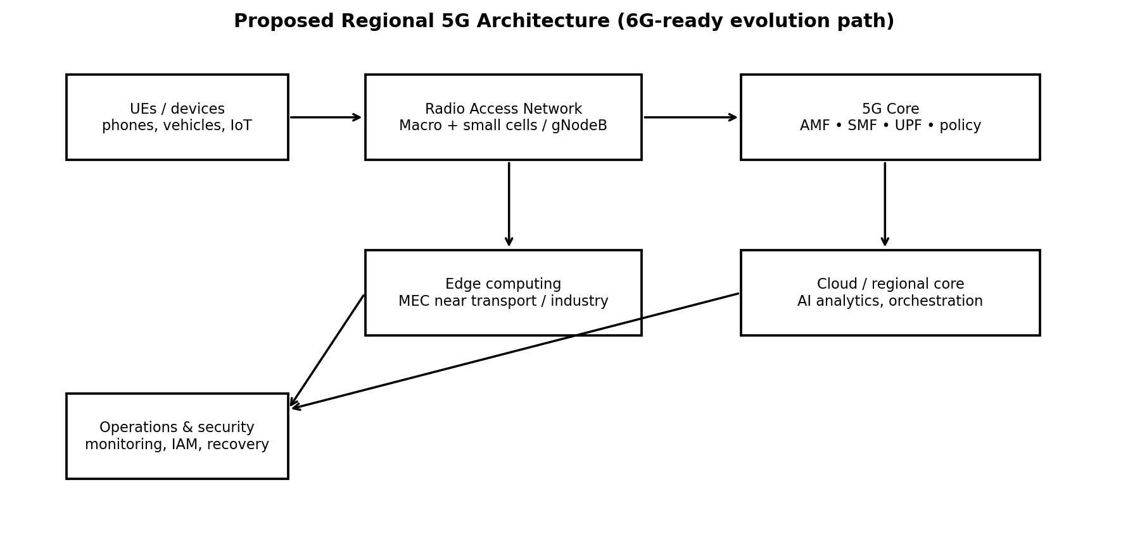
Figure 3. Conceptual architecture for the proposed regional network.
The recommended architecture uses macro gNodeBs as the broad coverage and mobility layer, mid-band radio for capacity, and targeted small cells for hotspots. A 5G Core provides control and user-plane functions; local edge computing reduces the transport distance for time-sensitive applications. A future 6G evolution path should be treated as a roadmap rather than as a presently deployable standardized system.

9.1 Logical network slices
Slice | Target services | Design treatment
eMBB | High-definition video, broadband and high user throughput | High-throughput scheduling, sufficient mid-band bandwidth, congestion control.
URLLC | Vehicle coordination, industrial control and selected remote-care functions | Prioritized QoS, low-latency edge path, redundancy and tested failover.
mMTC | Large populations of sensors and low-rate IoT devices | Efficient signaling, device grouping, power saving and scalable access.
Public safety | Emergency communications and disaster response | Priority/pre-emption where supported, resilient core/backhaul and fallback coverage.

9.2 Core, edge, AI and security
- AMF manages access and mobility signaling; SMF manages session establishment and user-plane selection; UPF forwards user traffic and can be placed near edge sites for local breakout. Policy, authentication and data-management functions complete the service-control path.
- Place edge compute near major transport corridors, hospitals and industrial campuses when latency measurements justify it. Keep regional cloud resources for analytics and workloads that do not require local response.
- Use AI-assisted traffic forecasting and radio-resource management as an optimization layer. Begin with a rule-based or conventional scheduling baseline, then compare the AI method using throughput, latency, blocking, fairness and energy metrics.
- Apply mutual authentication, encryption in transit, least-privilege access, secure management interfaces, software updates, anomaly detection, redundant backhaul and documented recovery procedures.
- Reduce energy use with adaptive sleep modes during low demand, efficient radio configurations, renewable-energy options where viable, and infrastructure sharing when it does not compromise resilience.

9.3 State/region-independent rollout phases
Phase | Deployment action | Validation gate
1. Baseline and survey | Collect busy-hour traffic, coverage, terrain/building data, existing assets and spectrum licence details. | Drive-test coverage and interference maps; verified traffic forecast.
2. Coverage foundation | Optimize low-band macro coverage and core/backhaul resilience. | Coverage holes, emergency reachability and mobility success meet targets.
3. Capacity layer | Deploy 3.5 GHz capacity and add small cells only at measured hotspots. | Cell utilization, throughput and blocking meet agreed targets.
4. Critical services | Add edge sites and dedicated QoS/slices for transport, healthcare, industrial and public safety. | End-to-end latency, reliability and failover tests pass application-specific limits.
5. High-capacity hotspots | Trial 28 GHz where blockage, site density and economics support it. | Measured throughput and availability justify operating cost.
6. 6G readiness | Evaluate AI-native networking and ISAC through pilots as standards and equipment mature. | Interoperability, safety, energy and cost evidence before scale-up.

10. Verification and performance indicators
Requirement / calculation | Design response | Evidence to collect | Status from analytical model
Busy-hour traffic 80 Erlangs | Traffic model and Erlang B sizing | Per-cell traffic distribution and call holding-time data | Calculated; site distribution still required
Blocking ≤ 2% | At least 92 channels for 80 Erlangs in ideal Erlang B model | Busy-hour blocking and handoff traffic | Meets in aggregate idealized model
Reuse cluster N = 7 | Reuse fraction 1/7; D ≈ 9.165 km | RF plan and measured co-channel interference | Geometric estimate only
SINR ≥ 15 dB | Coordinate channels, beams, sectors and filters | SINR maps across load and mobility | Supplied case fails at ≈ 13.81 dB
Mobility continuity | Optimize handoff thresholds and neighbor relations | Handover success, interruption, drop and ping-pong rates | Simple estimates only
Spectrum-band choice | Low band coverage, 3.5 GHz capacity, selective 28 GHz | Coverage, throughput, blockage and site-cost measurements | FSPL comparison calculated
Energy and resilience | Sleep modes, redundant backhaul and recovery plans | Energy per bit, outage duration and failover results | Requires field validation

11. Final recommendation
Recommend deployment with staged validation. First, verify traffic distribution and coverage using surveys and drive tests. Maintain low-band macro coverage for reach and resilience, use 3.5 GHz as the main capacity layer, and add micro/pico cells where measured demand justifies densification. Reserve 28 GHz for short-range high-capacity locations where line-of-sight and economics are favorable. The calculated cell area is approximately 10.392 km², the 19-cell geometric cluster area is 197.454 km², and the N = 7 reuse distance is approximately 9.165 km. Offered traffic is 80 Erlangs; 92 channels meet the 2% Erlang-B target, while 100 channels yield about 0.399% blocking under the model.
The interference example is the clearest immediate issue: co-channel-only C/I equals 15 dB, but combined co-channel and adjacent-channel interference gives about 13.81 dB, below the target. Interference mitigation and measured margin should therefore precede capacity expansion in affected areas. For mobility, the 6-second overlap corresponds to 100 m of travel at 60 km/h, and the simplified route interpretation implies about one handoff per minute. Critical services need measured end-to-end interruption and reliability evidence rather than reliance on this simplified estimate.
The design should proceed only after confirming actual licensed bandwidth, traffic geography, terrain and indoor losses, antenna configuration, backhaul capacity, power constraints, equipment availability, cybersecurity requirements and service-level targets. 6G concepts such as THz communication, AI-native networking and ISAC are included as future-facing options and should not be treated as currently guaranteed capabilities.

References
- UNIT 1 Assignment. ECA56 Advanced Wireless Communication Systems: CO1 Integrated Engineering Analysis and Planning Assignment. Supplied course document.
- CO-1 Assignment Question Paper. ECA56 Advanced Wireless Communication Systems. Supplied assessment brief.
- International Telecommunication Union (ITU), Radiocommunication Sector (ITU-R), Radio Regulations and World Radiocommunication Conference materials.
- 3rd Generation Partnership Project (3GPP), specifications and technical reports for 5G System and NR.

